**Objective : Developing Web Application/UI for Web Application**

**UI (HTML,CSS,JavaScript)/UX(Photoshop, Flash,..)**

**Course Title:**

1. **HTML**
2. **CSS**
3. **Java Script**
4. **Introduction BootStrap**
5. **HTML (Project-1)**
6. **HTML and CSS (Project-2)**
7. **HTML,CSS and Java Script (Project -3)**

**Front End Developer/UI Developer (User Interface)/Web Development**

**Full Stack Java Development 🡪 Web Application/Web Developer**

**Full Stack .Net Development 🡪 Web Application/Web Developer**

**Full Stack Java**

**Module-1 🡪 Front End**

**HTML**

**JavaScript**

**CSS**

**Module-2 🡪 Backend**

**Java**

**Servlet**

**JDBC**

**JSP**

**Spring Boot**

**Full Stack .Net**

**Module-1 🡪 Front End**

**HTML**

**Java Script**

**CSS**

**Module-2 🡪 Back End**

**C#.Net**

**ASP.Net**

**Full stack Python**

**Module-1**

**HTML**

**CSS**

**Java Script**

**Module2:**

**Python**

**Django/Flask**

**Duration: 45 sessions**

**Telegram-id: codewithsatishgupta**

**Upload course content**

**Introduction to Web**

**What is networking**?

Networking is logical or physical link between two or more devices.

**Advantage**

Sharing resources (software or hardware)

**What is ip-address?**

In networking each device or system is identified with a unique number called ip-address. This ip-address is given by network admins.

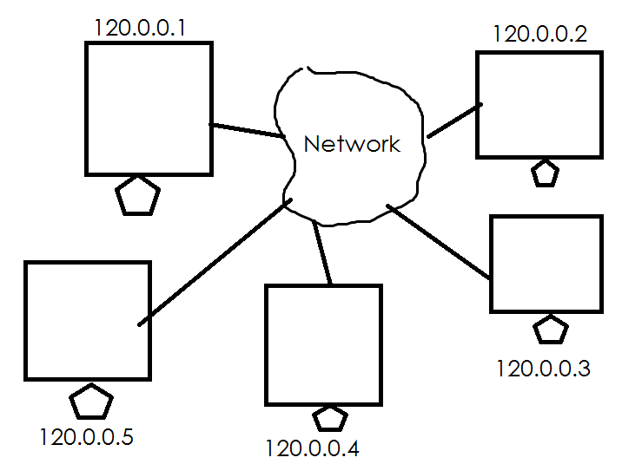

Networking required two programs.

1. Client
2. Server

Client who send request/input to server program

Server program which takes request from client process it and generate output/response.

Each server program in networking is identified with a unique number called portno.

**What is portno?**

Portno is integer number which is used to identify server running within system.

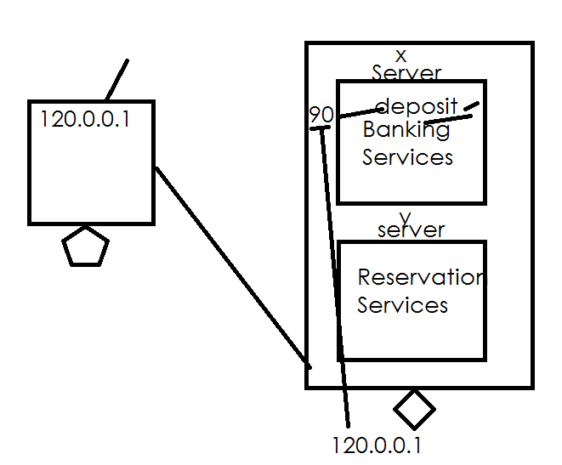

**What is protocol?**

A protocol defines set of rules and regulations to exchange information between two programs (client/server).

1. HTTP 🡪 Hyper Text Transfer Protocol
2. HTTPS 🡪 Hyper Text Transfer Protocol + SSL
3. FTP 🡪 File Transfer Protocol
4. SMTP 🡪 Simple Mail Transfer Protocol
5. TCP 🡪 Transmission Control Protocol
6. UDP 🡪 User Datagram Protocol

**What is hostname?**

Hostname is wrapper of ipaddress.

120.0.0.1 🡪 localhost/nit/naresh

**What is URL?**

URL stands for Uniform Resource Location

This URL consists of,

1. Ip-address
2. Portno
3. Application-name
4. Resource name

IPAddress of system where application is installed.

Portno is server protno where application is installed

Name of the application from which resource is accessed

Resource name 🡪 static resource or dynamic resource

<Http://120.0.0.1:8080/webapp1/index.html> 🡪 www.nareshit.com

URI 🡪 Uniform Resource Identification

URN 🡪 Uniform Resource Name

What is ARPANET?

--> ARPANET full form is Advanced Research

Projects Agency NET.

--> ARPANET was the very first network that

was created using a distributed form of

control. It was also considered to be one of

the first networks to implement the protocols

of TCP/IP. The creation of ARPANET basically

paved the way for the beginning of the web

and internet with the help of these

technologies.

--> The basic idea behind the creation of

ARPANET was to communicate with all the

scientific users that existed amongst any

university or institute.

--> The introduction of ARPANET happened

in 1969 by the Advanced Research Projects

Agency also known as ARPA that was a part

of the US Department of Defense. The

establishment of ARPANET took place with

the help of PCs that different colleges had.

The technology helped in sharing the

information as well as messages amongst the

computers.

What is Internet?

--> Internet is a global network that connects

billions of computers across the world with

each other and to the World Wide Web. It

uses standard internet protocol suite (TCP/IP)

to connect billions of computer users

worldwide.

--> It is set up by using cables such as optical

fibers and other wireless and networking

technologies. At present, internet is the

fastest mean of sending or exchanging

information and data between computers

across the world.

What is Web?

The World Wide Web—commonly referred to

as WWW, W3, or the Web—is a system of

interconnected public webpages accessible

through the Internet. The Web is not the

same as the Internet: the Web is one of many

applications built on top of the Internet.

Tim Berners-Lee proposed the architecture of

what became known as the World Wide Web.

He created the first web server, web browser,

and webpage on his computer at the CERN

physics research lab in 1990. In 1991, he

announced his creation on the alt.hypertext

newsgroup, marking the moment the Web

was first made public.

The system we know today as "the Web"

consists of several components:

--> The HTTP protocol governs data transfer

between a server and a client.

http

https

--> To access a Web component, a client

supplies a unique universal identifier, called a

URL (uniform resource locator) or URI

(uniform resource identifier) (formally called

Universal Document Identifier (UDI)).

--> HTML (hypertext markup language) is the

most common format for publishing web

documents.

Linking, or connecting resources through

hyperlinks, is a defining concept of the Web,

aiding its identity as a collection of connected

documents.

What is W3C?

Soon after inventing the Web, Tim Berners-

Lee founded the W3C (World Wide Web

Consortium) to standardize and develop the

Web further. This consortium consists of core

Web interest groups, such as web browser

developers, government entities,

researchers, and universities.